**Ideation Phase**

**Brainstorm & Idea Prioritization Template**

|  |  |
| --- | --- |
| Date | 19 September 2022 |
| Team ID | NM2023TMID08993 |
| Project Name | AI Enabled Car parking Using OpenCV |
| Maximum Marks |  |

**Brainstorm & Idea Prioritization Template:**

Reducing energy use in your home saves you money, increases our energy security, and reduces the pollution that is emitted from non-renewable sources of energy. If you are planning to install a small renewable energy system to [make your own electricity](https://www.energy.gov/energysaver/planning-home-renewable-energy-systems), such as a solar electric system or small wind turbine, reducing your electricity loads is the first step because it allows you to purchase a smaller and less expensive system.

**Step-1: Team Gathering, Collaboration and Select the Problem Statement**

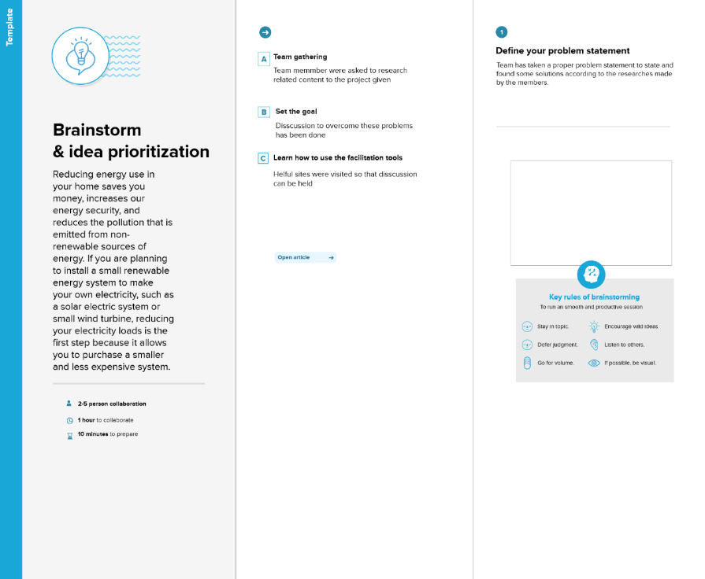

**Step-2: Brainstorm, Idea Listing and Grouping**

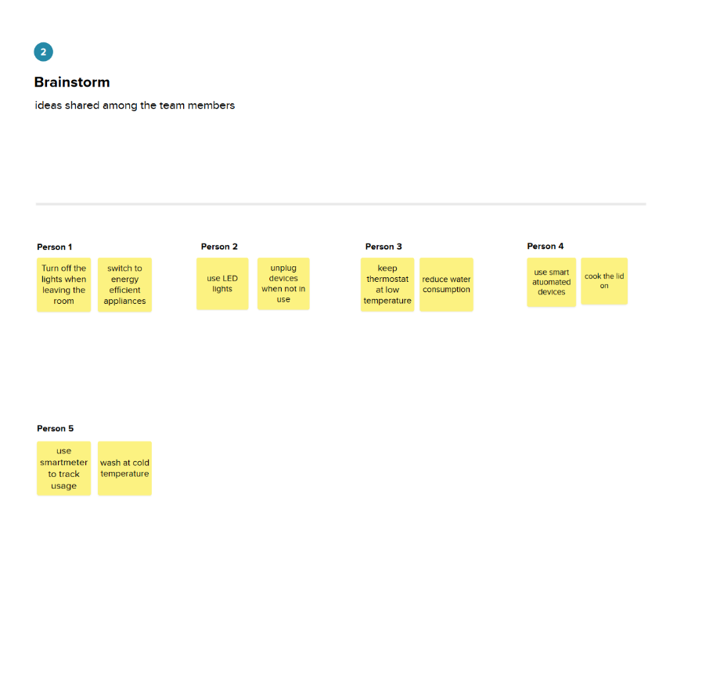

**Step-3: Idea Prioritization**

